**PROJECT TITLE:**

A CRM APPLICATION FOR LAPTOP RENTALS

**NAME OF THE STUDENT:** Karlakunta Hari Krishna

**NAME OF THE COLLEGE:** K.S.R.M College of Engineering

**SKILLWALLET-ID:** SWUID20240130218

**PROJECT DEVELOPER ACCOUNT:**

HariKrishna_Karlakunta@ksrmce.com

**TRAILHEAD-URL:**

https://www.salesforce.com/trailblazer/jocmb6siojwp59tkn6•

**PROJECT OVERVIEW:**

This project aims to create a CRM solution specifically for laptop rentals, addressing the dilemma of effectively distributing rental laptops while enhancing customer relationships. This aims to provide a more seamless and tight solution using customer relationship management (CRM) systems. By doing this, it hopes to boost customer satisfaction, streamline store work processes, and increase overall productivity in general.

Also, the project demonstrates that tailored email campaigns provide great engagement with potential renters when prospective customers are engaged with the rental business.

**OBJECTIVES:**

**1.Operations objective:** In reducing the manual burden of managing laptop hire, streamlining and automating the essential processes

**Outcome:** Implement the capabilities to manage rental requests and approvals automatically and track payments

**2.Improve Communication with Customers:** When your communication with the customers gets integrated more , it will be easier to take feedback and provide them information.

**Specific Outcome:** Automated email alerts (Rental Confirmation, Reminder, Feedback collection & more),

**Salesforce Key Features & Concepts Applied:**

1. **Customer 360:** Unified profiles per customer to manage rental history, preferences and contact data for a customizable experience
2. **Email Integration:** Automated Communication to send out confirmations, payment reminders, special promotions and lead follow-ups.
3. **Service Cloud:** Effective case management to effectively manage and resolve requests and inquiries from customers.
4. **Salesforce Flow:** Automate key processes like rental approvals, delivery scheduling & payment handling for operational productivity.
5. **Analytics and Dashboards:** Real-time analytics and visual dashboards to keep track of rental trends, customer behaviour.

**Detailed Designing Steps:**

**1.Salesforce Platform Setup:** Development of the core CRM platform, confirming configurations meet project specifications.

**SCREENSHOTS:**

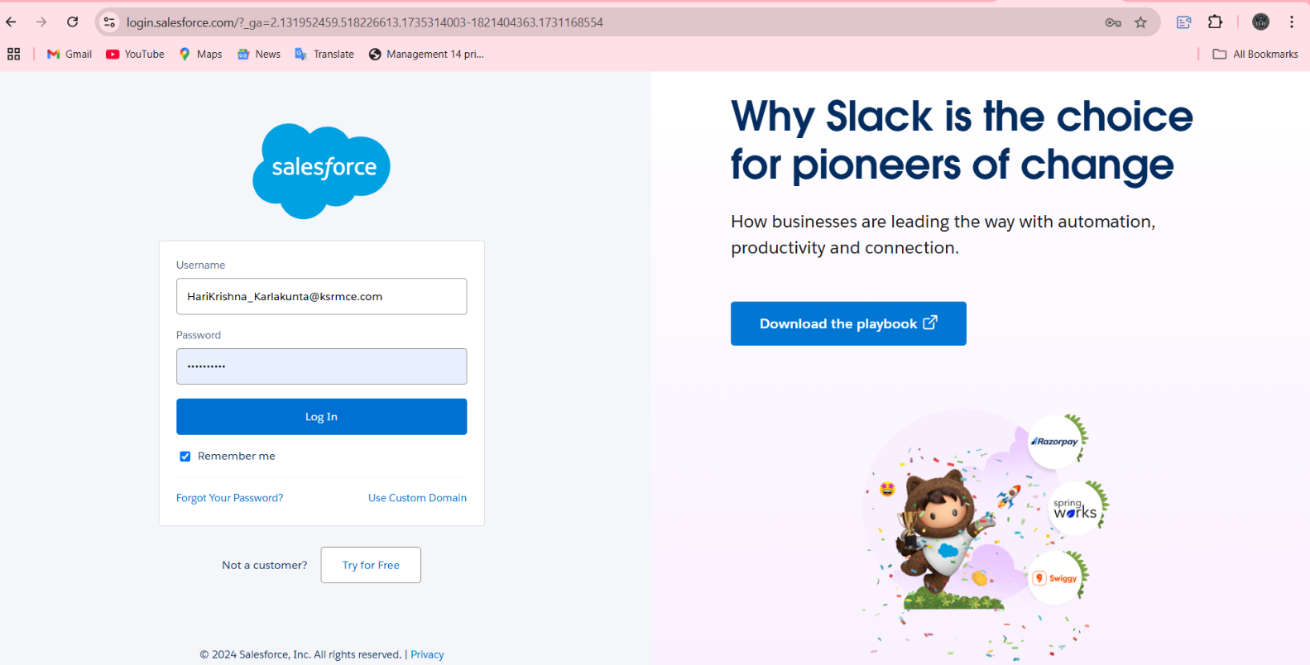

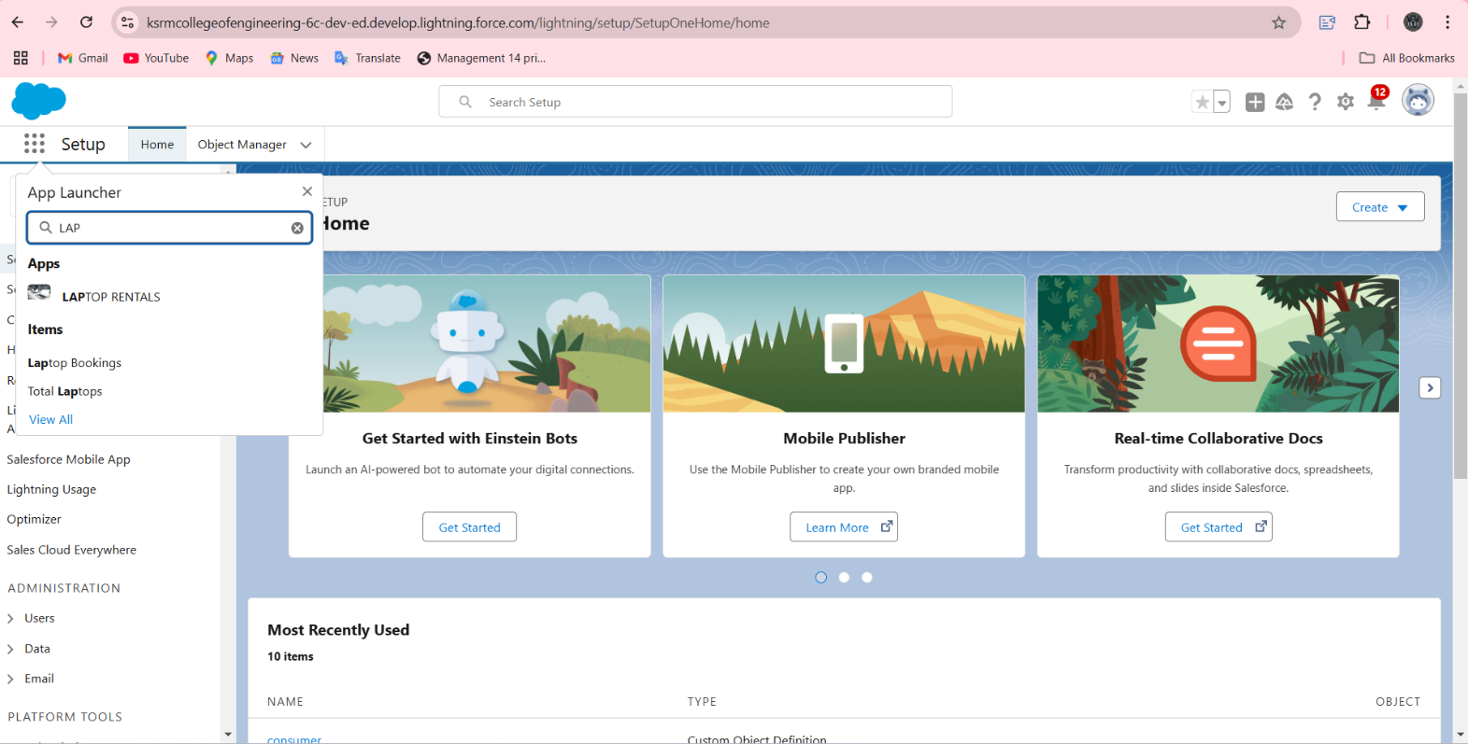

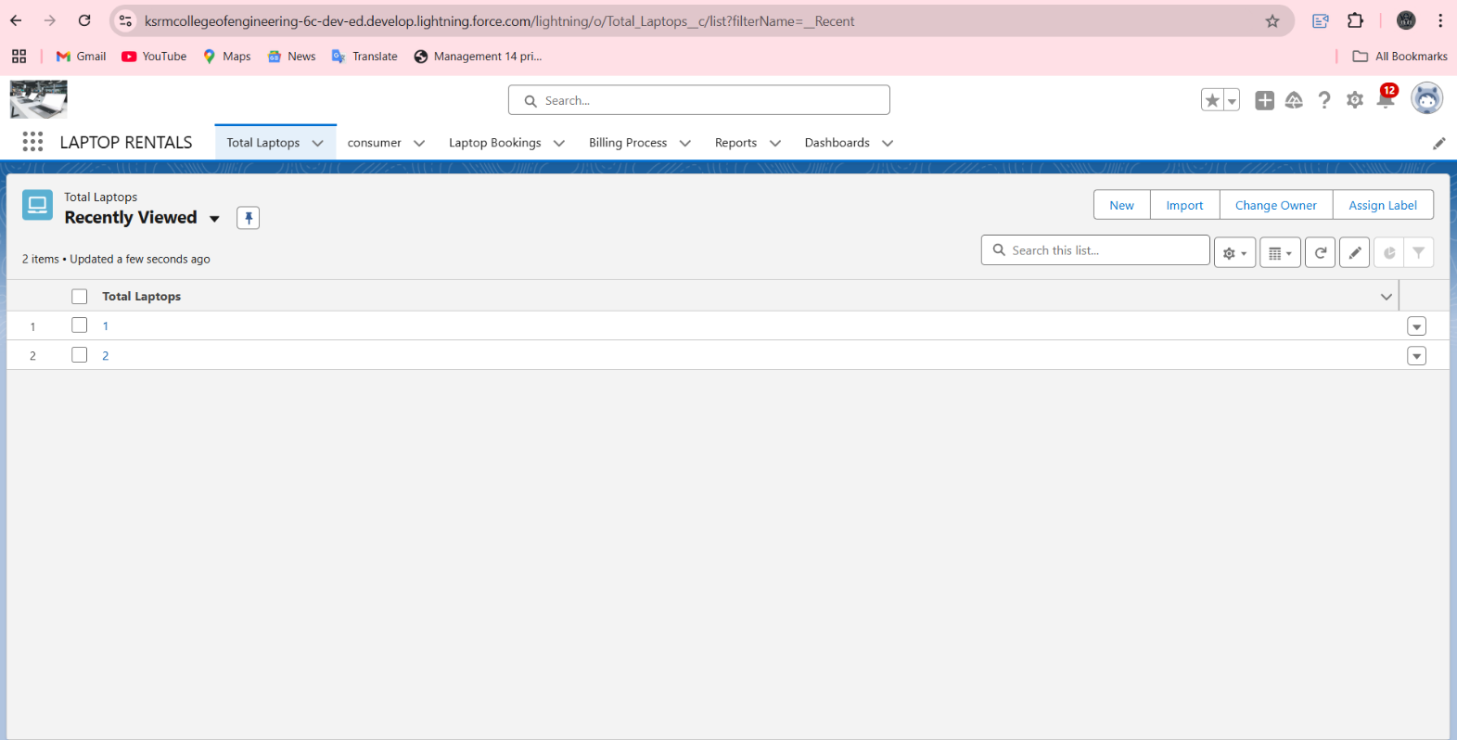

**2.Object Creation:**Modelling with objects and setting it up, for example, for managing laptops, rentals, customers, and inventory (like Bookings, Billing Processes, Total Laptops).

**SCREENSHOTS:**

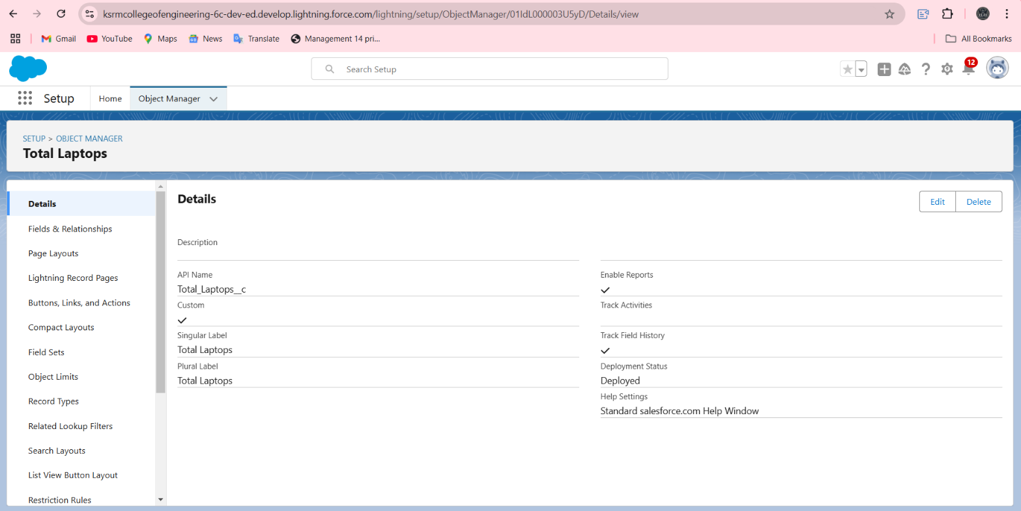

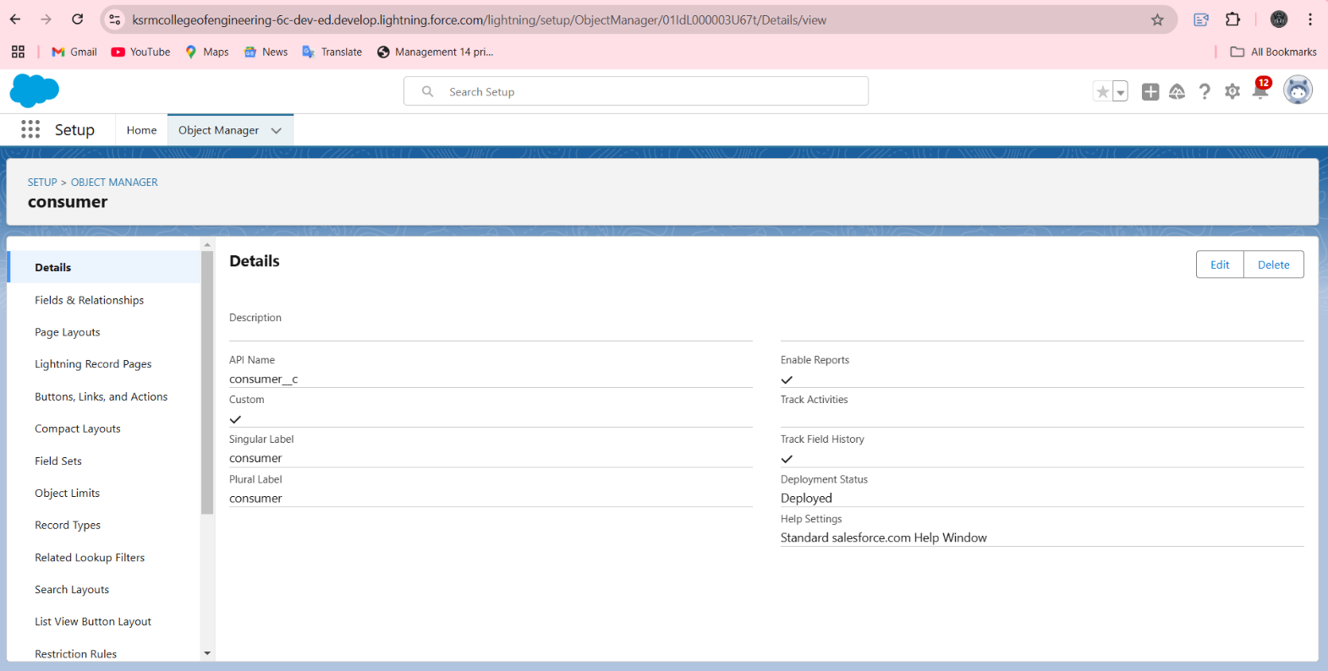

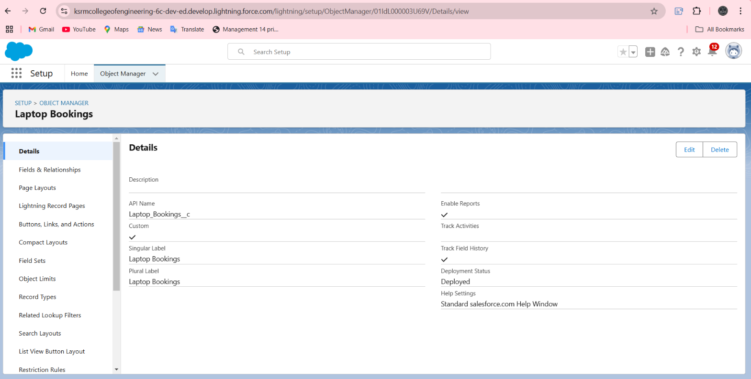

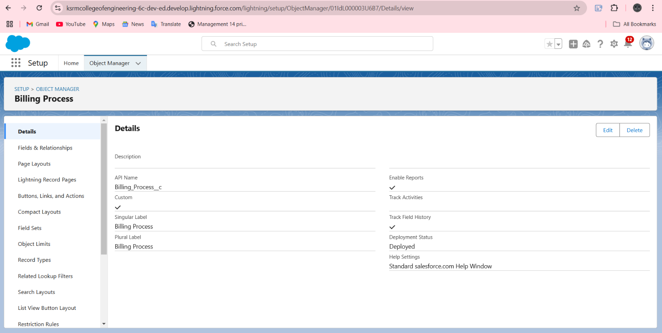

**3.Tabs:** Creating intuitive tabs for easy navigation with the right amount of information like Rentals, Customers, and Reports.

**SCREENSHOTS:**

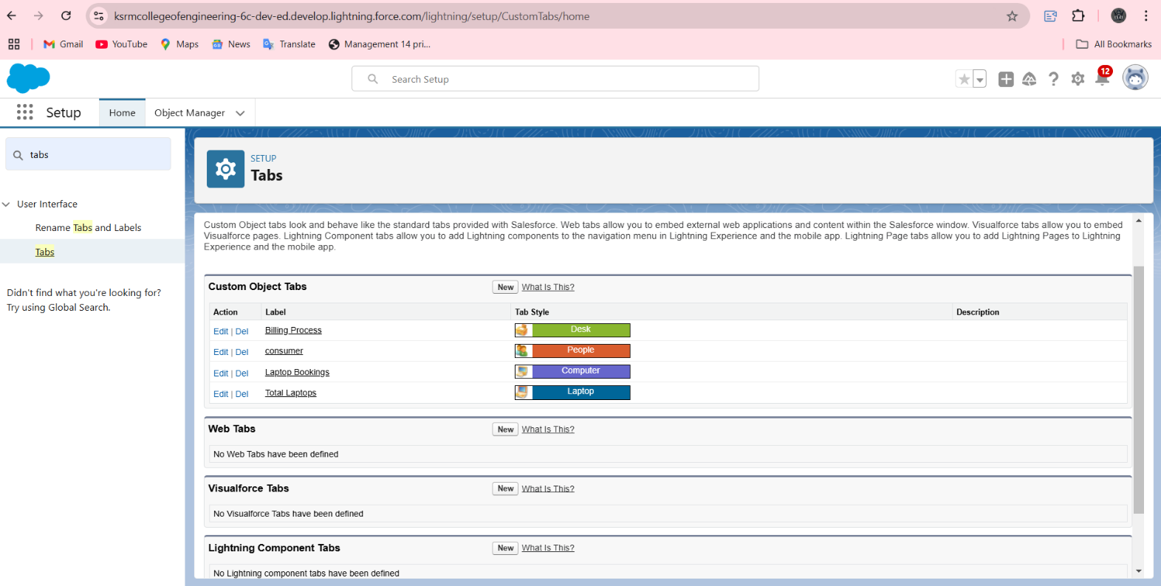

**4.The LightningApp:**Set-up an intuitive Lightning App for managing the store with a simplified user-interface for an improved experience for store staff and customers.

**SCREENSHOTS:**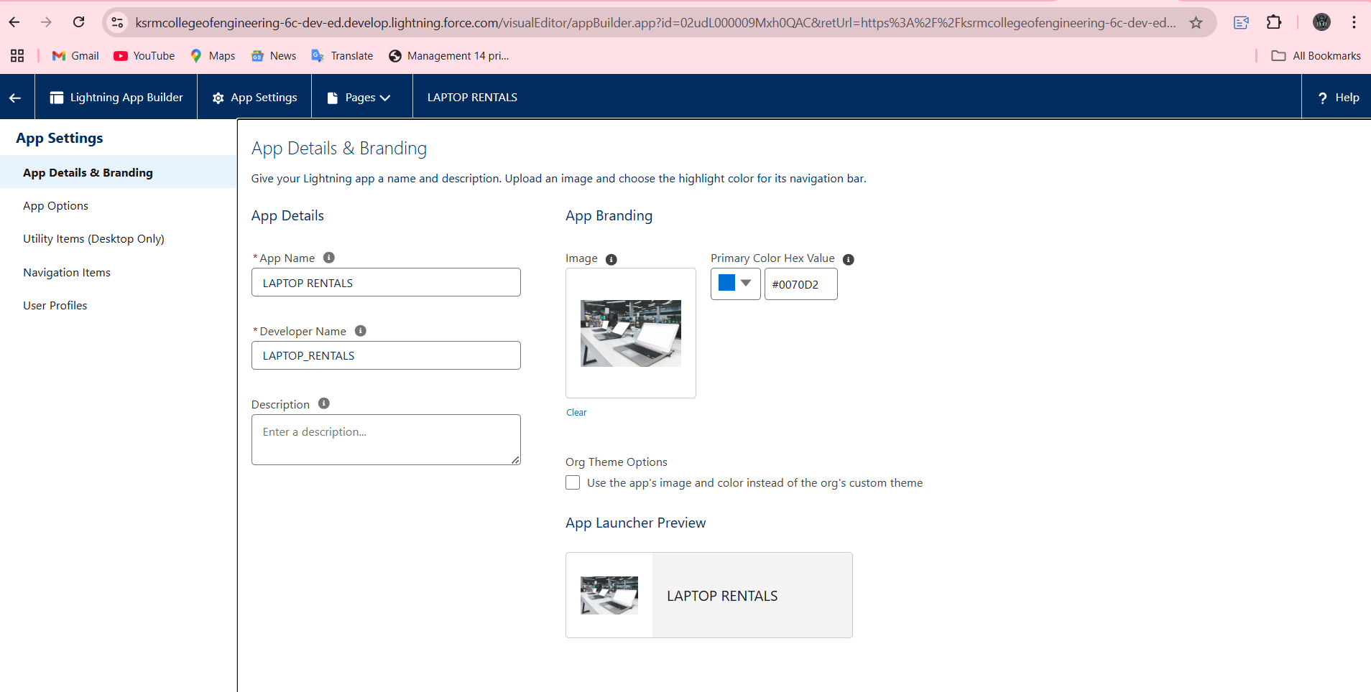

**5.Fields:** Creating and personalizing fields to capture essential information such as rental period, customer details, and payment information.

**SCREENSHOTS:**

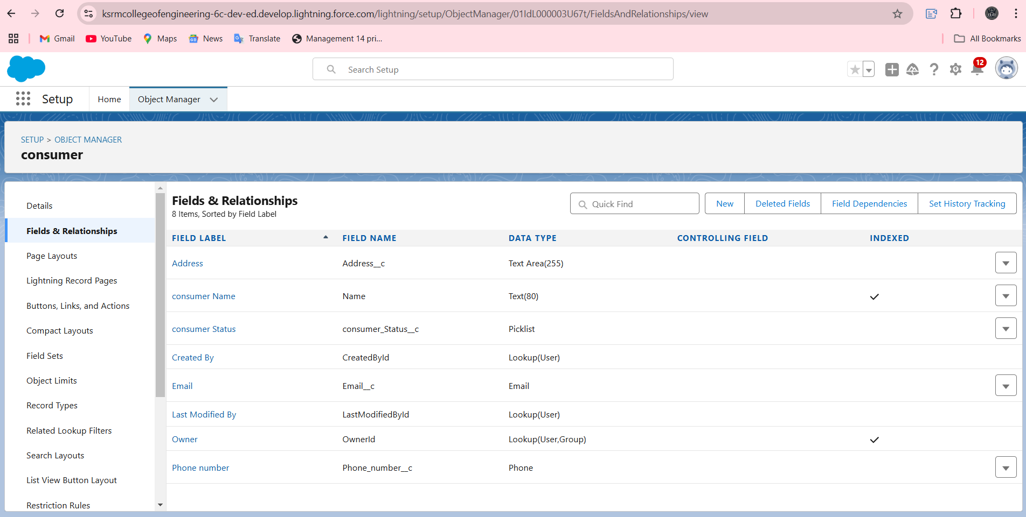

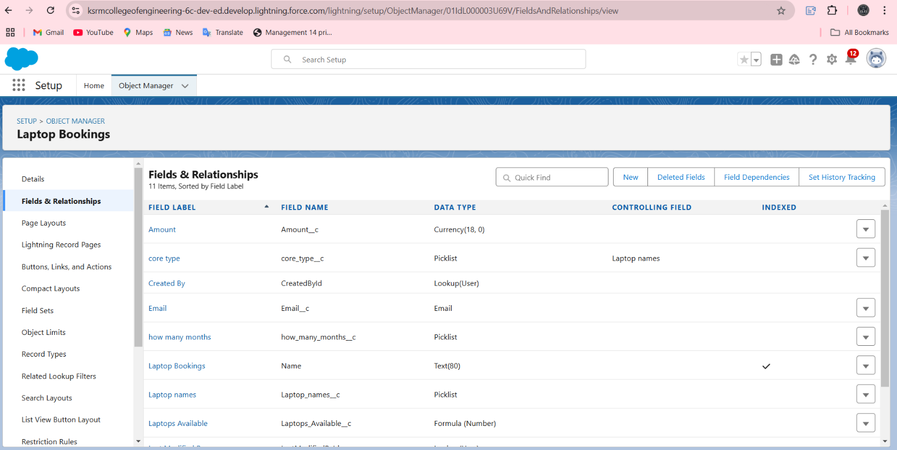

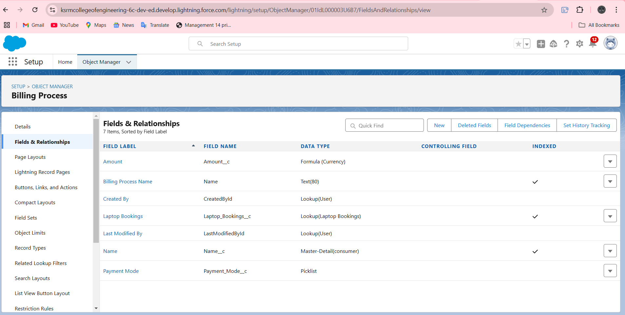

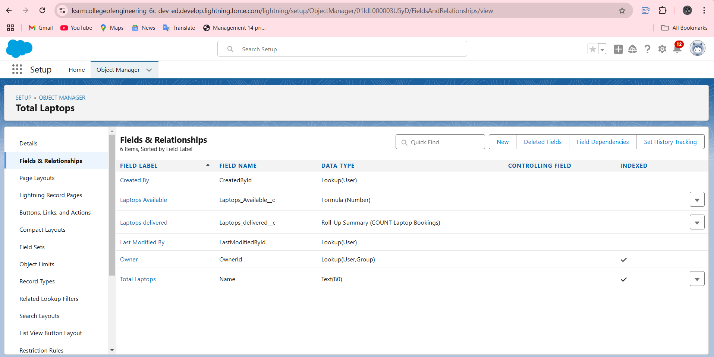

**6.Validation Rules:** Setting up validation rules to ensure data integrity, including required fields for rental records and email formatting.

**SCREENSHOTS:**

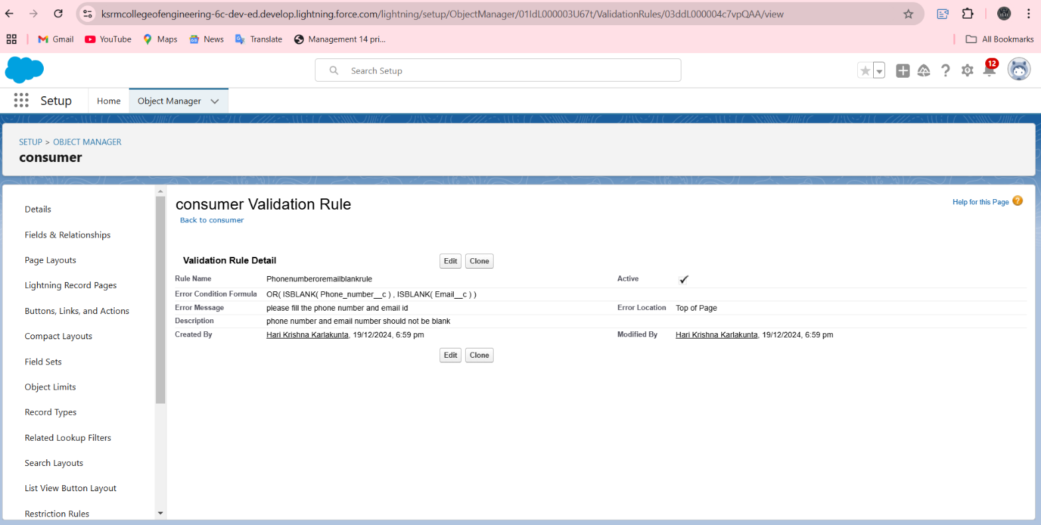

**7.Profiles:** Creating user profiles to control access permissions and protect data, based on the role of the user, like Owner and Agent.

**SCREENSHOTS:**

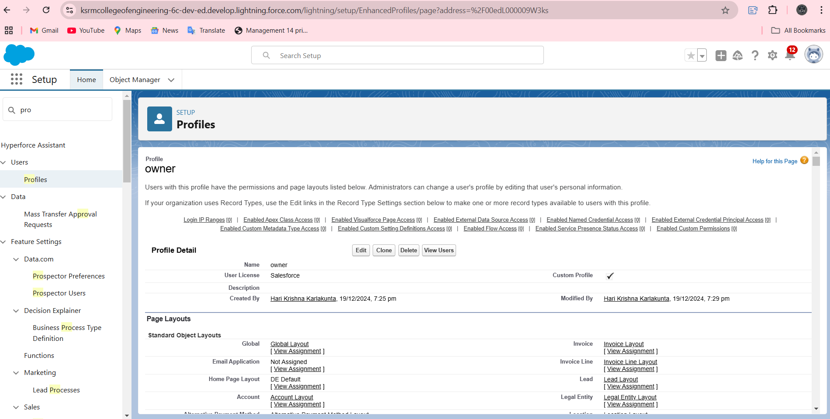

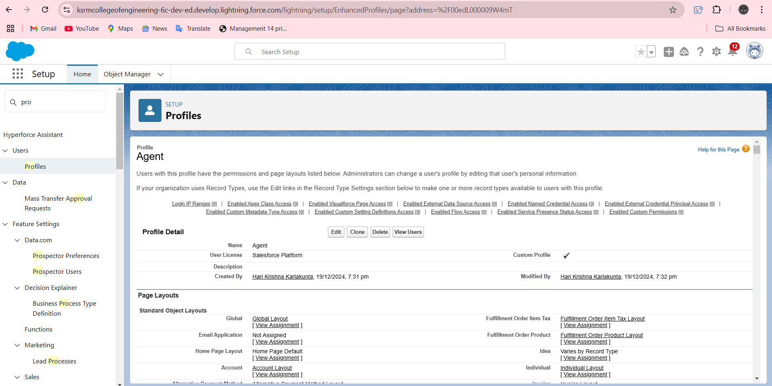

**8.Roles and Hierarchy:** Define role hierarchies to specify user responsibilities and control the data visibility in the organization, including the Owner role.

**SCREENSHOTS:**

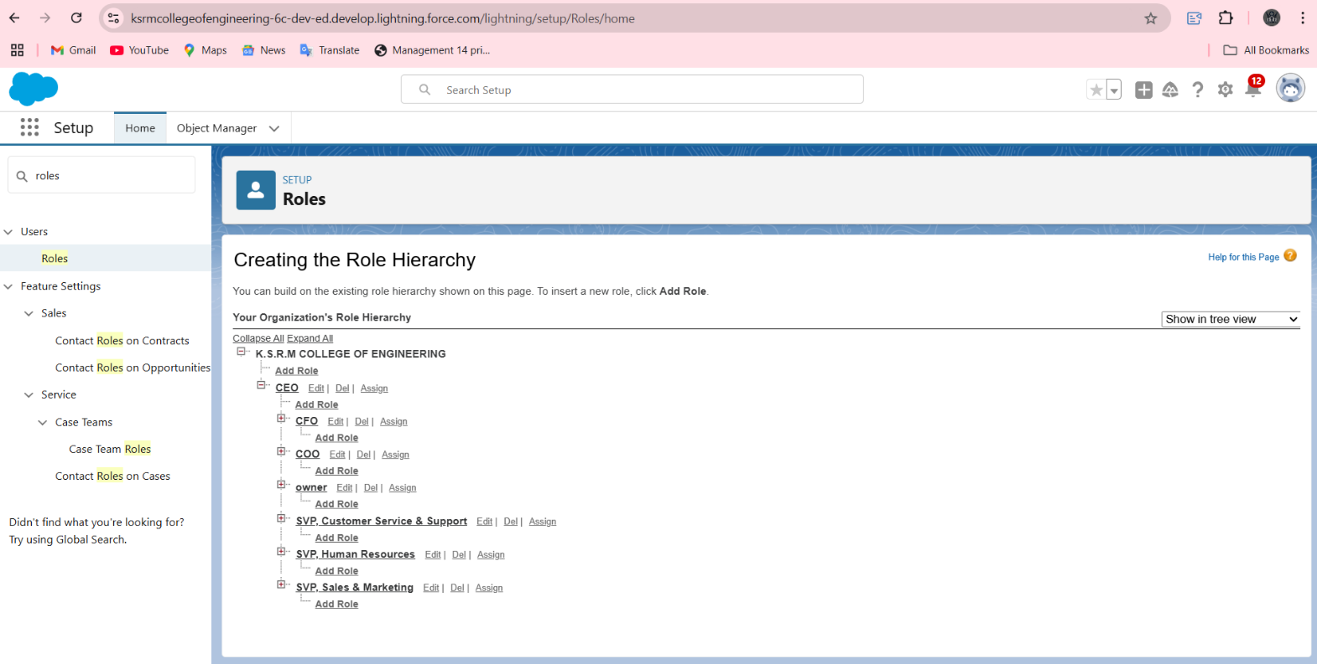

**9.Users:** These are account setups for the store operator, Store admin, and Store manager to use the CRM system as securely and efficiently as possible.

**SCREENSHOTS:**

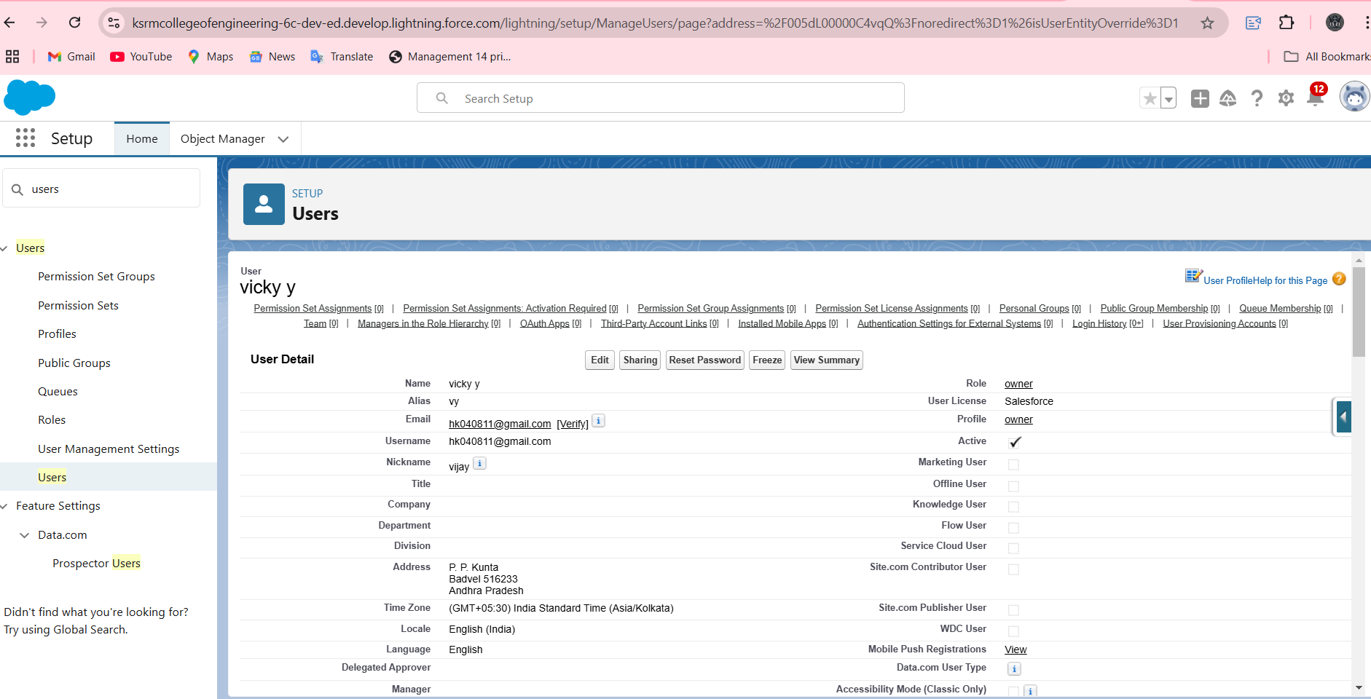

**10.Flows:** The automation via Salesforce Flows of certain business processes like rental approval, payment confirmation, delivery notification, etc.

**SCREENSHOTS:**

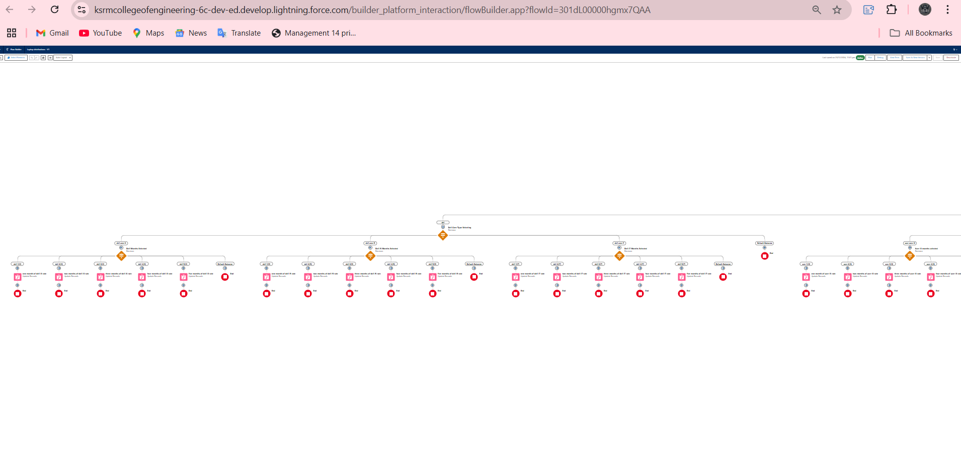

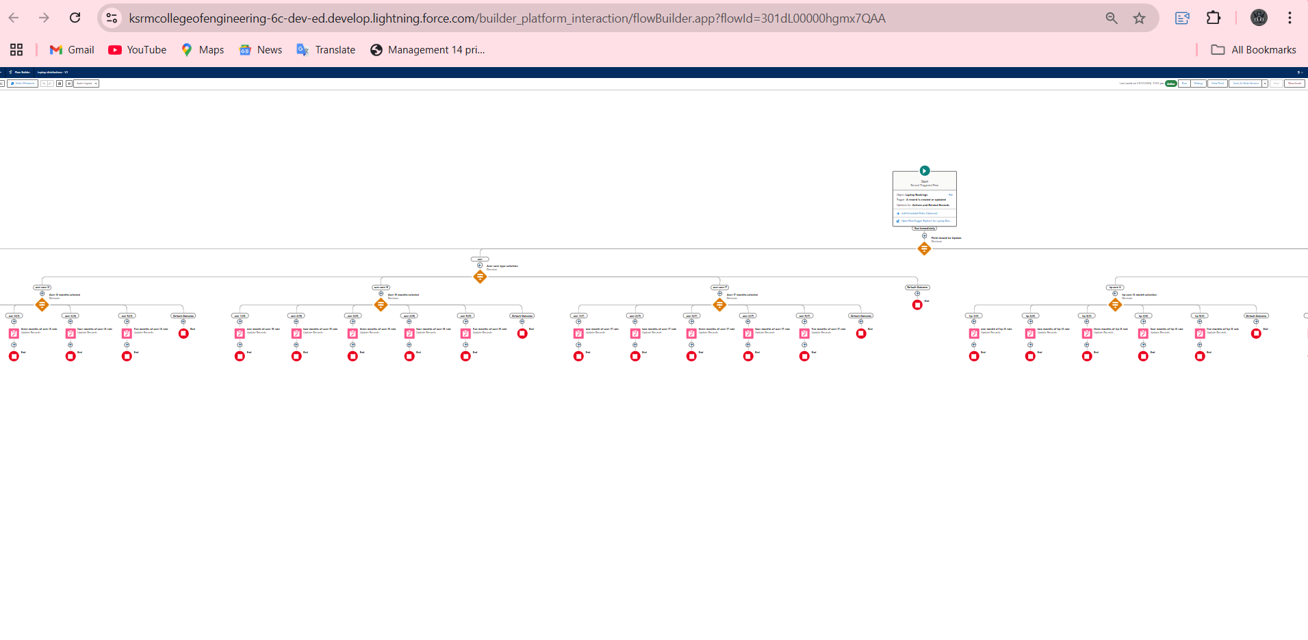

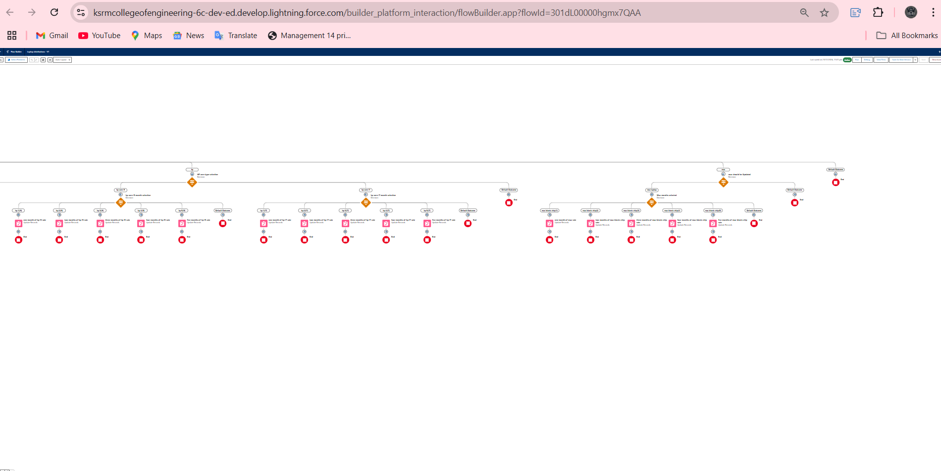

**11.APEX:** customizing your own logic using APEX to perform complex automation tasks, such as inventory updates and customer notifications.

**SCREENSHOTS:**

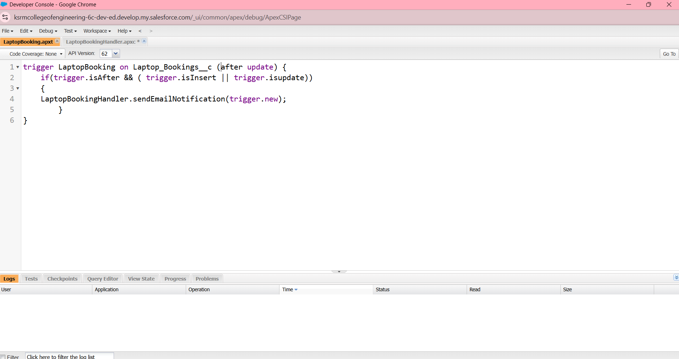

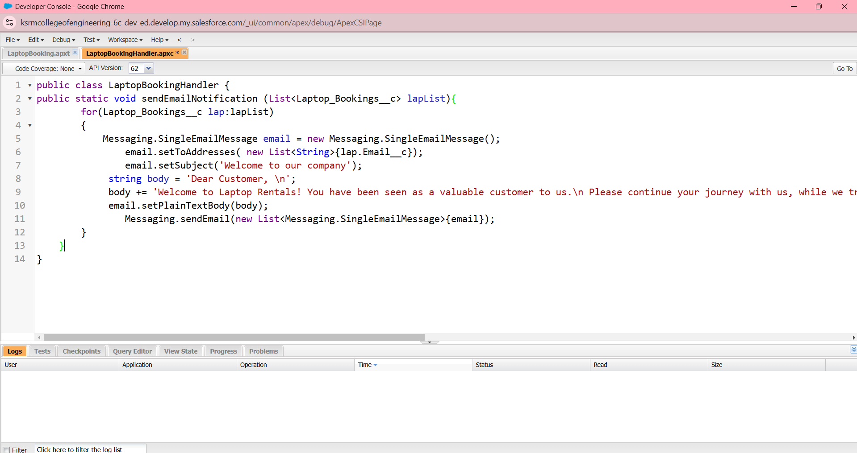

**12.Reports:** creating in-depth reports to examine rental trends, customer engagement, and revenue growth.

**SCREENSHOTS:**

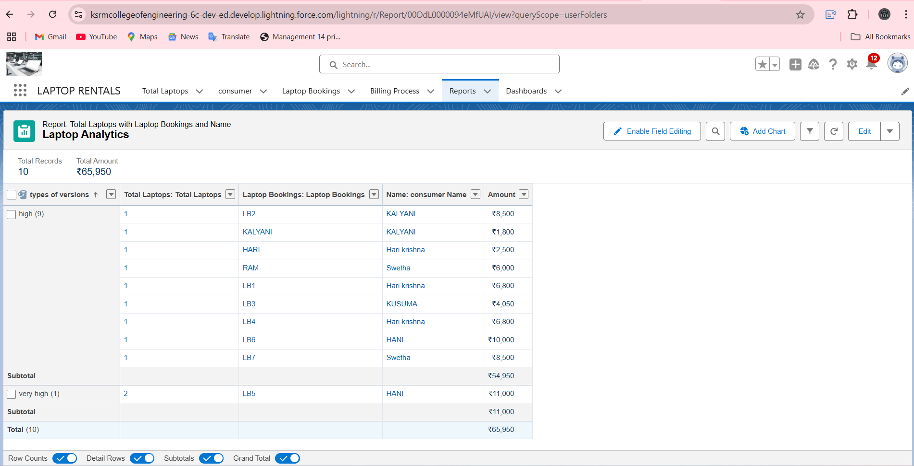

**13.Dashboards:** Creating interactive dashboards to provide a real-time snapshot of critical metrics like pending rentals, payments, and overall business health.

**SCREENSHOTS:**

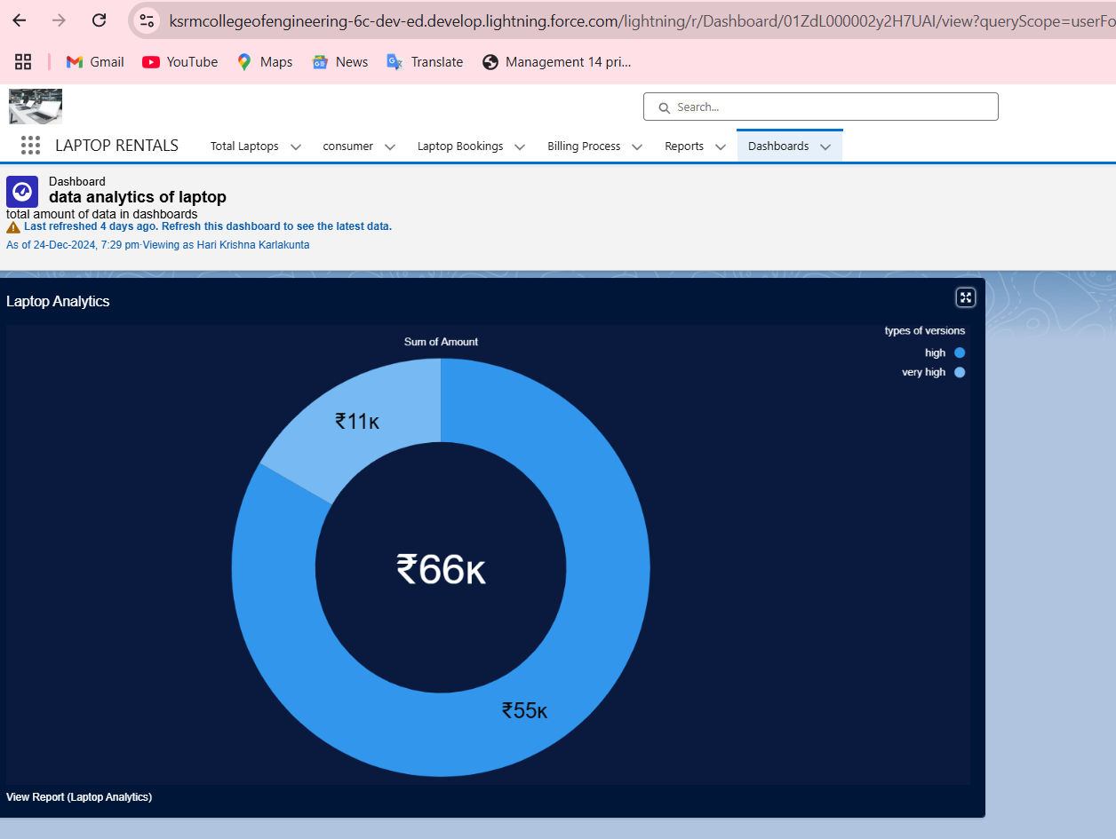

**TESTING & VALIDATION:**

**Consumer Mail Testing:**

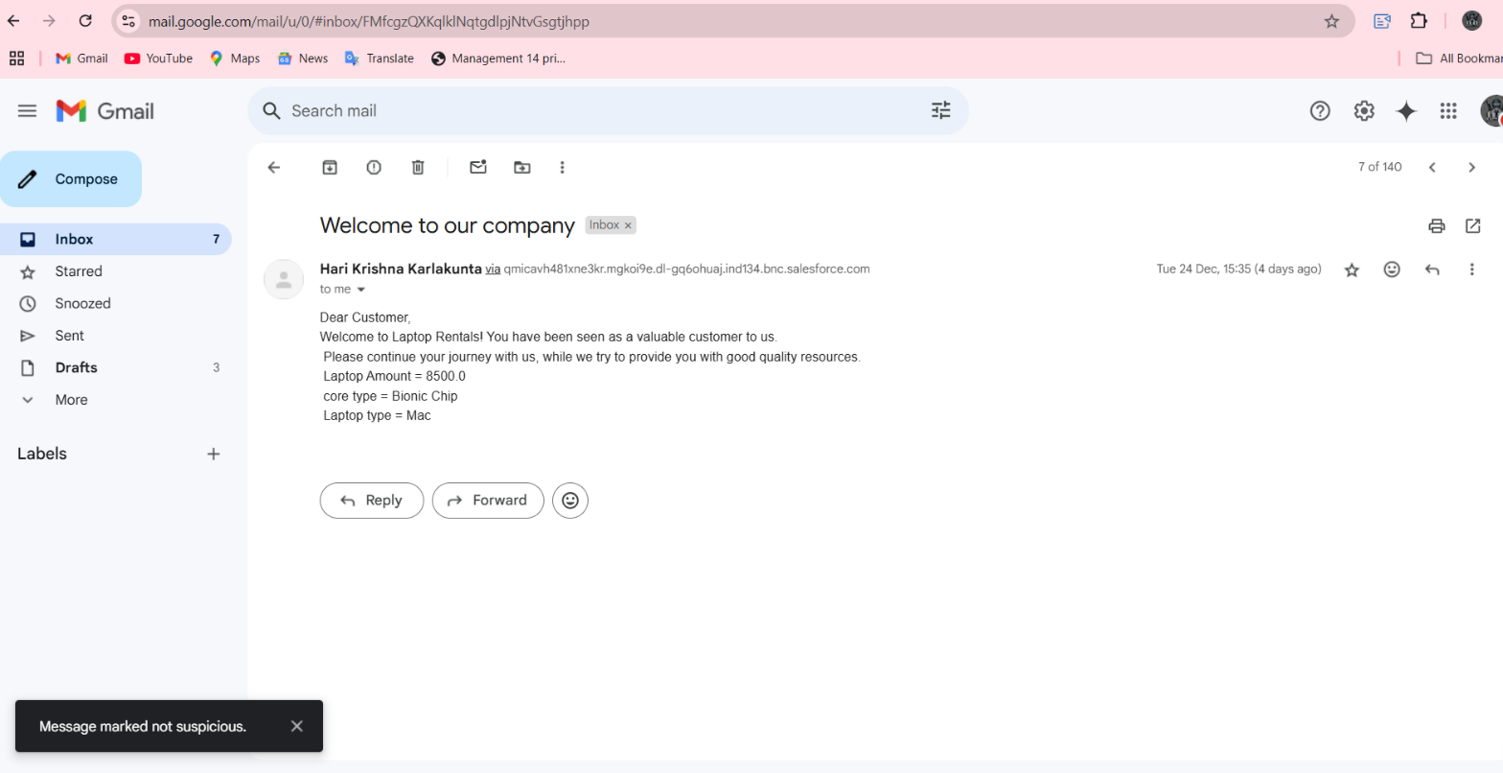

**Owner Daily Report Testing:**

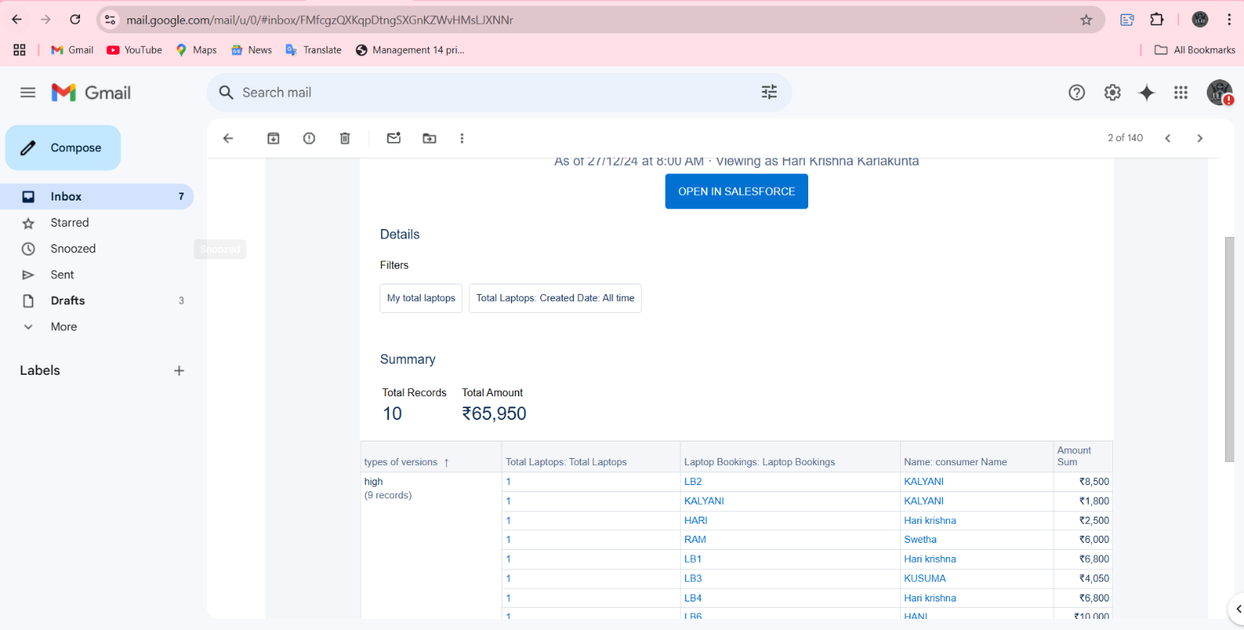

**Scenarios Addressed:**

**Rental Management:** Manage rental requests, approvals and deliveries effectively.

**Customer Interactions:** Automatically emailing rental confirmations, reminders, and follow-ups to improve customer interaction.

**Data Accuracy:** Validation rules are enforced to make sure that the data entry is consistent, correct and without any errors.

**User Access Control:** Role-based permissions for secure data access according to user roles.

**Performance Monitoring:** Track your key metrics on an up-to-date basis using reports and dashboards that give real-time business insights.

**CONCLUSION:**

**Summary of Achievements:**

1.Easy Laptop Rental Management, with Automation for critical processes Rental approval, delivery and communication automation, etc.

2**.Consolidated Data Cleaning Activities:** Gained control of errors by putting to use validation rules and common processes to keep data uniform and accurate.

3.**Better Customer Engagement:** Communication with the customers was improved by using automated emails for confirmations, reminders, and follow-ups.

4.**Improved Business Operations:** There are role-based access controls which can lead to secure, stream-lined workflow and efficient resource management.

5.**Actionable Insights:** Real-time reports and dashboards to drive data-based decisions and track key business metrics

6.**Business Outcomes:** Improved customer satisfaction, streamlined store processes, and supported business growth.